What is business development?
PMA4U is here to help your Business Development for your Business
So, for starters, let PMA4U define the term.
Business development definition
Business development is the creation of long-term value for an organization from customers, markets, and relationships. Although this formal definition is straightforward, it lacks the ability to paint a clear picture of what function a business development team serves within an organization.
What does a business development representative do?
There is one core responsibility of business development: growing your business. The strategies to operationalize and accomplish this goal will vary greatly across industries, but the idea is generally the same for all companies. Business development professionals need to stay knowledgeable about the current market to effectively target opportunities for growth. This means having expert knowledge of your target audience and engaging with (yes, this means cold calling) prospects to generate new business.
Every business needs to acquire new customers to grow, but not every potential customer is going to be the right fit for your business. Evaluating whether a prospect is qualified to buy what your business is selling is essential to business development.
Day to day, these prospecting activities are carried out by teams of sales or business development representatives (SDR or BDR for short).
BDRs are responsible for prospecting and qualifying leads before handing them off to the sales team to nurture the relationship and close the deal. This process is crucial in keeping the company’s revenue engine running and creating long-term value.
How business development representatives qualify leads
Every business has a target audience that they wish to reach – in other words, they have an ideal prospect they want to sell to. Often, this is based on what your existing customer base looks like and is defined using a customer profile.
One of the most used qualification frameworks that exists today is called BANT, which stands for:
- Budget: Does the prospect have available resources to invest?
- Authority: Is this prospect the ultimate decision maker?
- Needs: What are the biggest problems that this prospect is looking to solve with my product?
- Timeline: How soon are they looking to buy?
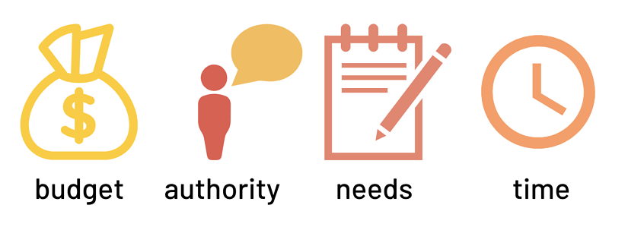It’s necessary for business development representatives to become subject matter experts on the set criteria they are given for qualifying prospects. This ensures that every sales opportunity they set up has a higher probability of closing and will move down the funnel more quickly.
Sales vs. business development
Although both sales and business development aim to grow new business, the two roles differ greatly and serve distinct purposes. Earlier in this document we learned that business development is essential to the sale process. The BDR team is responsible for pushing qualified leads further down the sales funnel, but they do not close deals themselves.
That’s where sales come in.
The primary function of the sales team is to generate revenue. Sales reps are responsible for demonstrating the product, making negotiations, and eventually closing the deal. Converting prospects into customers is much easier to accomplish when sales and business development work together to streamline the sales process.
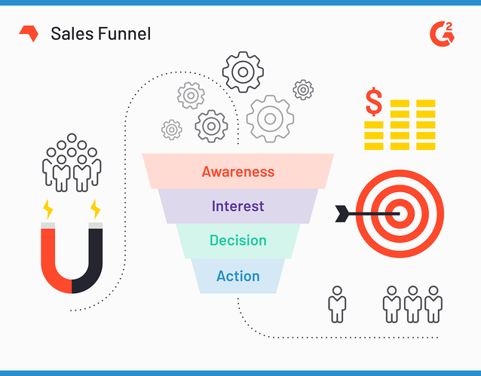
Separating these two roles within a company allows each team to specialize in their specific function and help grow the business more efficiently.
Both roles require a similar set of skills — this allows for career development opportunities for BDRs who want to move into a closing role down the line. The relationship-building skills learned in the business development position are easily transferable and build a foundation for the skills necessary to succeed in sales, marketing, or even customer success. Many business development teams operate as a subset of the sales department and are held to similar metrics.
Measuring the impact of business development efforts
Sales metrics for a business development team are going to vary based on what a company’s sales cycle looks like. Since the primary function of the role is to generate new opportunities to sell, one of the easiest ways to quantify this data is by looking at BDR-influenced sales pipeline, or the number of potential deals created because of business development efforts.
Many BDR teams hold quotas that align with the company’s overall revenue goals. To achieve revenue goals (that rest on the shoulders of the sales team), business development must be consistently generating healthy pipeline.
Although metrics vary by company, common ways to track BDR activity are through prospecting activities (cold calls and outbound emails), number of appointments booked, and amount of sales pipeline generated. All this data is normally stored and tracked using CRM software.

